Pick a local business and relate the concept of operations to the changes the business had to adhere to face the current climate under COVID. In your report, you can address changes in the business model, compare operations in the pre, during, and post COVID. Do you think that operations is fundamentally changing? What are your projections? Support your report with personal experiences during COVID.
Instructions:
• The written document should be about (1000) words.
• The report should be written in an academic format paper. You should include an Introduction, body, and a conclusion. Use of peer-reviewed and other trusted references and sources is mandatory.
Tip: For this, I have chosen a local café. You can relate to local café where you are from, I believe that is a similar situation. To survive during the lock-down, they start producing coffee boxes using third party food apps (such as uber eat)
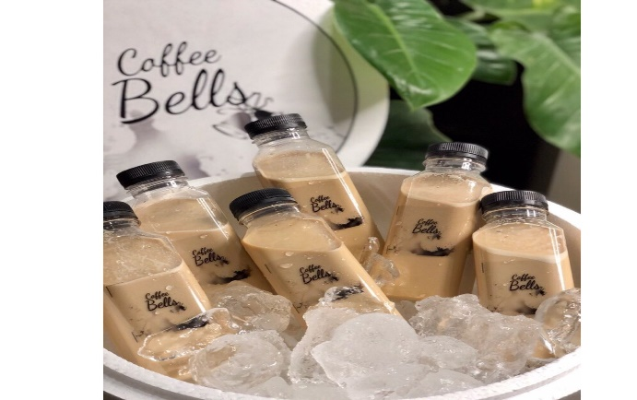
They also introduced new products other than coffee, frozen boxes of Mojito taking advantages of the hot climate during the summer.
